**Lesson 3 Demo 3**

**Installation of Jenkins on Windows**

Steps to be followed:

1. Install Java JDK 8 or 11 on Windows machine
2. Download Jenkins executable to install Jenkins on windows machine
3. Execute Jenkins executable to install Jenkins
4. Access Jenkins using localhost as URL and port as 8080

**Step 1: Install Java JDK 8 or 11 on Windows machine**

1. Download JDK 11 from Oracle Website to install Oracle JDK on Windows machine:  
     
   ***https://www.oracle.com/java/technologies/javase-jdk11-downloads.html***

**Step 2: Download Jenkins executable to install Jenkins on windows machine.**

1. Download Windows executable installer from Jenkins’s website into your system:

***https://www.jenkins.io/download/thank-you-downloading-windows-installer-stable***

**Step 3: Execute Jenkins executable to install Jenkins**

1. Follow below screens to install Jenkins on Windows:

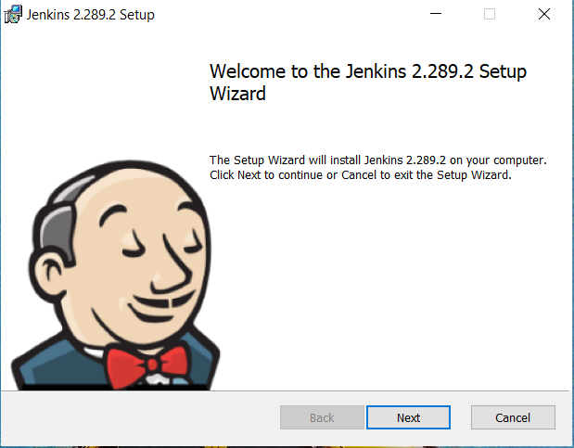

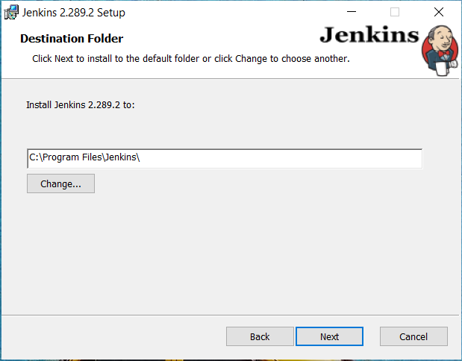

3.2 While installing Jenkins you can either install service as Local System or you can provide service account which can be used to deploy Jenkins’s service.

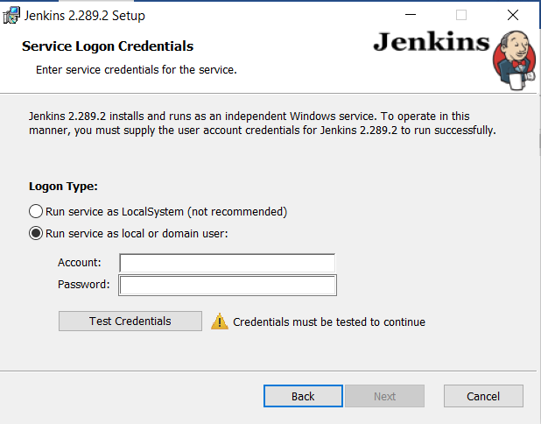

**Step 4: Access Jenkins using localhost as URL and port as 8080**

***http://localhost:8080***